CSE 404 HW 01

1.

${\left(2A\right)}^{T}= 2\left[\begin{matrix}1 & 2 \\ 2 & 1 \\ 3 & 4\end{matrix}\right]= \left[\begin{matrix}2 & 4 \\ 4 & 2 \\ 6 & 8\end{matrix}\right]$

${\left(A-B\right)}^{T}=it is not possible to compute since they dont have the same size$

${\left(3B^{t}-A\right)}^{T}={\left(3 \left[\begin{matrix}1 & 2 & 3 \\ 0 & 1 & 2\end{matrix}\right]-\left[\begin{matrix}1 & 2 & 3 \\ 2 & 1 & 4\end{matrix}\right]\right)}^{T}={\left(\left[\begin{matrix}3 & 6 & 9 \\ 0 & 3 & 6\end{matrix}\right]-\left[\begin{matrix}1 & 2 & 3 \\ 2 & 1 & 4\end{matrix}\right]\right)}^{T}={\left[\begin{matrix}2 & 4 & 6 \\ -2 & 2 & 2\end{matrix}\right]}^{T}=\left[\begin{matrix}2 & -2 \\ 4 & 2 \\ 6 & 2\end{matrix}\right]$

${\left(-A\right)}^{T}E= \left[\begin{matrix}-1 & -2 \\ -2 & -1 \\ -3 & -3\end{matrix}\right]\left[\begin{matrix}3 & -2 \\ 2 & 4\end{matrix}\right]= \left[\begin{matrix}-7 & -6 \\ -8 & 0 \\ -15 & -6\end{matrix}\right]$

${\left(C+2D^{T}+E\right)}^{T}=it is not possible to compute since matrix E has different size$

2.

$AB=\left[\begin{matrix}1 & 4 \\ 3 & 2\end{matrix}\right]\left[\begin{matrix}2 & -1 \\ -3 & 4\end{matrix}\right]= \left[\begin{matrix}-4 & 15 \\ 0 & 5\end{matrix}\right]$

$BA= \left[\begin{matrix}2 & -1 \\ -3 & 4\end{matrix}\right]\left[\begin{matrix}1 & 4 \\ 3 & 2\end{matrix}\right]= \left[\begin{matrix}-1 & 6 \\ 9 & -4\end{matrix}\right]$

1. They are different.

3.

$v_{1}∙v_{2}=\left(-2, 0,1\right)∙\left(0, 1,0\right)=\left(0+0+0\right)=0$

$v_{1}∙v_{3}=\left(-2, 0,1\right)∙\left(2, 0,4\right)=\left(-4+0+4\right)=0,$

$v_{2}∙v_{3}=\left(0, 1,0\right)∙\left(-2, 0,1\right)=\left(0+0+0\right)=0$

$v_{1}=\left(-2,0,1\right)=>\left(\frac{-2}{\sqrt{5}},\frac{0}{\sqrt{5}},\frac{1}{\sqrt{5}}\right) prove: \sqrt{{\frac{-2}{\sqrt{5}}}^{2}+0^{2}+{\frac{1}{\sqrt{5}}}^{2}}=1$

$v_{2}=\left(0,1,0\right) prove: \sqrt{0^{2}+1^{2}+0^{2}}=1$

$v_{3}=\left(2,0,4\right)=>\left(\frac{2}{\sqrt{20}},\frac{0}{\sqrt{20}},\frac{4}{\sqrt{20}}\right) prove: \sqrt{{\frac{2}{\sqrt{20}}}^{2}+0^{2}+{\frac{4}{\sqrt{20}}}^{2}}=1$

4.

$while m and n are bigger than 0 \left(m>0 and n>0\right), rank of the matrix xy^{T} is 1$

$if m or n is 1, then the rank is 1 since there is only one pivot point$

$\left[\begin{matrix}1 \\ 2\end{matrix}\right] or \left[\begin{matrix}1 & 2\end{matrix}\right]$

$if m and n are bigger than 1, still the rank is 1 since every row can be divisible$ $$by a row in the matrix$$

$X=\left[\begin{matrix}1 \\ 2 \\ 3\end{matrix}\right] Y=\left[\begin{matrix}4 & 5 & 6 & 7\end{matrix}\right], XY^{T}=\left[\begin{matrix}4 & 5 & 6 & 7 \\ 8 & 10 & 12 & 14 \\ 12 & 15 & 18 & 21\end{matrix}\right],which row 2 and row 3 are multiple of row 1. So row 2 and row3$ $$would cancel out, making\left[\begin{matrix}4 & 5 & 6 & 7 \\ 0 & 0 & 0 & 0 \\ 0 & 0 & 0 & 0\end{matrix}\right] that only has 1 pivot point.$$

$But if m or n is 0, then the rank is 0.$

$at this point, XY^{T} would be an empty matrix, which the rank is 0.$

5.

1. ‘i’ in X represents the row number, and ‘i’ in Y represents the column number.

By multiplying X and Y matrices,

6.

7.

* 1. eigenvalues
 $\det\left(\left[\begin{matrix}2-λ & 1 & 3 \\ 1 & 1-λ & 2 \\ 3 & 2 & 5-λ\end{matrix}\right]\right)=\left(2-λ\right)*\det\left[\begin{matrix}1-λ & 2 \\ 2 & 5-λ\end{matrix}\right]-1*det\left[\begin{matrix}1 & 2 \\ 3 & 5-λ\end{matrix}\right]+3*det\left[\begin{matrix}1 & 1-λ \\ 3 & 2\end{matrix}\right]=\left(2-λ\right)*\left(\left(1-λ\right)\left(5-λ\right)-4\right)-\left(5-λ-6\right)+3\left(2-\left(1-λ\right)\left(3\right)\right)=\left(-λ^{3}+8λ^{2}-13λ+2\right)-\left(5-λ-6\right)+\left(9λ-3\right)=-λ^{3}+8λ^{2}-3λ$

 $λ=0 \& λ=4-\sqrt{13} \& λ=4+\sqrt{13}$

2. Eigenvector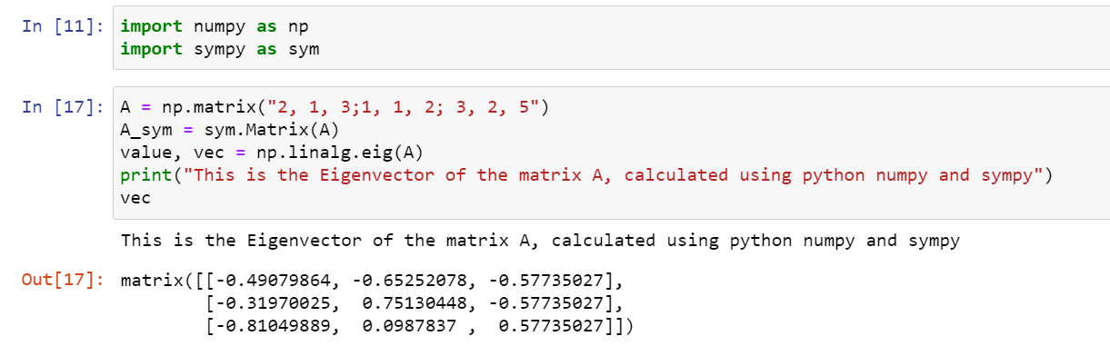

1. Eigen Decomposition of A
$A=UΛU^{T}=\left[\begin{matrix}-0.4908 & -0.6525 & -0.5773 \\ -0.3197 & 0.7513 & -0.5773 \\ -0.8105 & 0.0988 & 0.5773\end{matrix}\right]*\left[\begin{matrix}4+\sqrt{13} & 0 & 0 \\ 0 & 4-\sqrt{13} & 0 \\ 0 & 0 & 0\end{matrix}\right]*\left[\begin{matrix}-0.4908 & -0.3197 & -0.8105 \\ -0.6525 & 0.7513 & 0.0988 \\ -0.05773 & -0.5773 & 0.5773\end{matrix}\right]=$

2. Rank of A
 $A=\left[\begin{matrix}2 & 1 & 3 \\ 1 & 1 & 2 \\ 3 & 2 & 5\end{matrix}\right]=>divide R1 by 2=\left[\begin{matrix}1 & 0.5 & 1.5 \\ 1 & 1 & 2 \\ 3 & 2 & 5\end{matrix}\right]=>R2-R1=\left[\begin{matrix}1 & 0.5 & 0.5 \\ 0 & 0.5 & 0.5 \\ 3 & 2 & 5\end{matrix}\right]=>R3-3*R1=\left[\begin{matrix}1 & 0.5 & 0.5 \\ 0 & 0.5 & 0.5 \\ 0 & 0.5 & 0.5\end{matrix}\right]=>divide R2 by 0.5=\left[\begin{matrix}1 & 0.5 & 0.5 \\ 0 & 1 & 1 \\ 0 & 0.5 & 0.5\end{matrix}\right]=>R3-0.5*R2=\left[\begin{matrix}1 & 0.5 & 0.5 \\ 0 & 1 & 1 \\ 0 & 0 & 0\end{matrix}\right]$

  1. So, the rank is 2
3. No, because not all eigen values are positive, 0 is one of them.
4. Yes, since all eigen values are non-negative.
5. Yes, since the determinant of A is 0.

$2*det\left[\begin{matrix}1 & 2 \\ 2 & 5\end{matrix}\right]-1*det\left[\begin{matrix}1 & 2 \\ 3 & 5\end{matrix}\right]+3*det\left[\begin{matrix}1 & 1 \\ 3 & 2\end{matrix}\right]=2-1\left(-1\right)+3\left(-1\right)=0$